Task 2: Deploy a Sample index.html File on Nginx
Outcome
A sample index.html file is deployed on the Nginx web server and is accessible through a web browser using the server's IP address.
Objective
To learn how to deploy a static HTML webpage on an Nginx web server and verify that the webpage is accessible to users over HTTP.
Prerequisites
- Ubuntu Linux machine or virtual machine
- Sudo privileges
- Internet connection
- Nginx web server
- Web browser
- Basic knowledge of Linux commands
Step-by-Step Implementation
Step 1: Update the System Packages
Implementation:
Open the terminal and execute the following command:
sudo apt update
This command updates the package repository information.
Screenshot Evidence
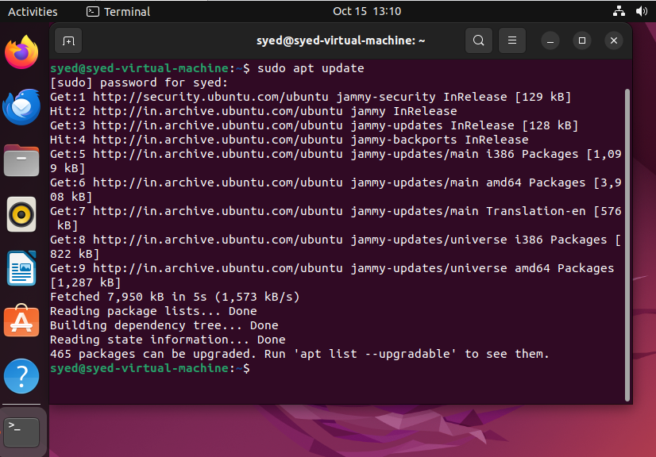

Step 2: Install Nginx
Implementation:
Execute the following command to install Nginx:
sudo apt install nginx -y
Check the installed version:
nginx -v
Screenshot Evidence
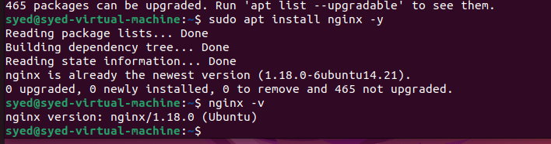

Step 3: Start and Verify Nginx
Implementation:
Start the Nginx service:
sudo systemctl start nginx
Enable Nginx to start automatically at boot:
sudo systemctl enable nginx
Check the service status:
sudo systemctl status nginx
Expected status:
Active: active (running)
Screenshot Evidence
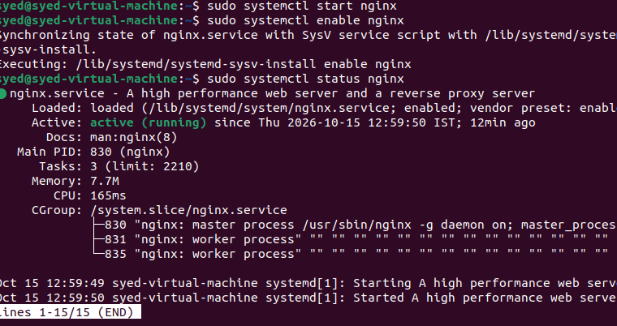
Step 4: Create the Sample index.html File

Implementation:
Open the default Nginx website directory:
cd /var/www/html
Create or edit the HTML file:
sudo nano index.html
Enter the following HTML code:
<!DOCTYPE html>
<html>
<head>
<title>My Nginx Website</title>
</head>
<body>
<h1>Welcome to My Nginx Website!</h1>
<p>This webpage is deployed using Nginx.</p>
</body>
</html>
Save the file using Ctrl + O, press Enter, and exit using Ctrl + X.
Configuration Table
Parameter | Value
Web Server | Nginx :- nginx -v
File Name | index.html :- ls -l /var/www/html total 8
Directory | /var/www/html :- cd /var/www/html  pwd
Protocol HTTP :- | : Allow port 80 using command :- sudo ufw allow 80/tcp
Page Title | My Nginx Website :- sudo nano /var/www/html/index.html
Screenshot Evidence
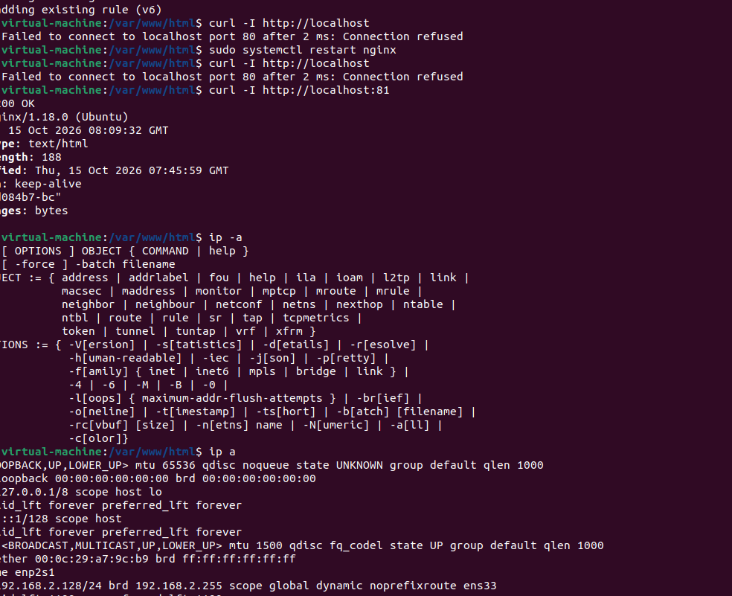

Step 5: Verify the HTML File
Implementation:
Execute the following command:
cat /var/www/html/index.html
Verify that the HTML code is saved correctly.
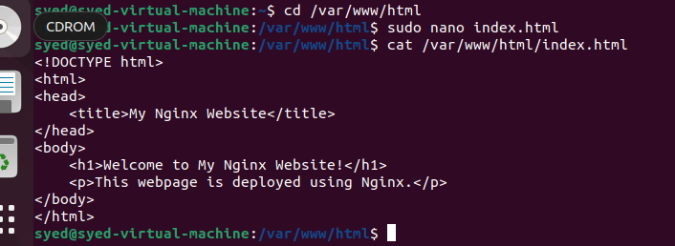

Step 6: Test the Nginx Web Server
Implementation:
Execute the following command:
curl http://localhost
The response should contain the HTML content, including:
<h1>Welcome to My Nginx Website!</h1>
If curl is not installed, execute:
sudo apt install curl -y
Screenshot Evidence
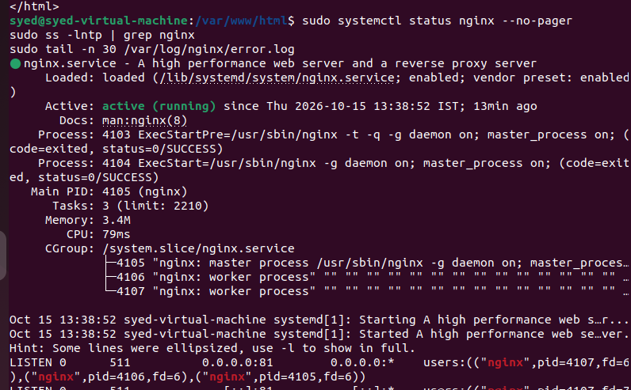

Step 7: Access the Webpage Through a Browser
Implementation:
Find the server's IP address:
hostname -I
Open a web browser and enter:
http://YOUR_SERVER_IP
Replace YOUR_SERVER_IP with the actual IP address of your Ubuntu machine.
For example:
http://192.168.140.128
The webpage should display the heading Welcome to My Nginx Website!
For remote or cloud servers, ensure that firewall rules allow inbound HTTP traffic on TCP port 80.
Screenshot Evidence
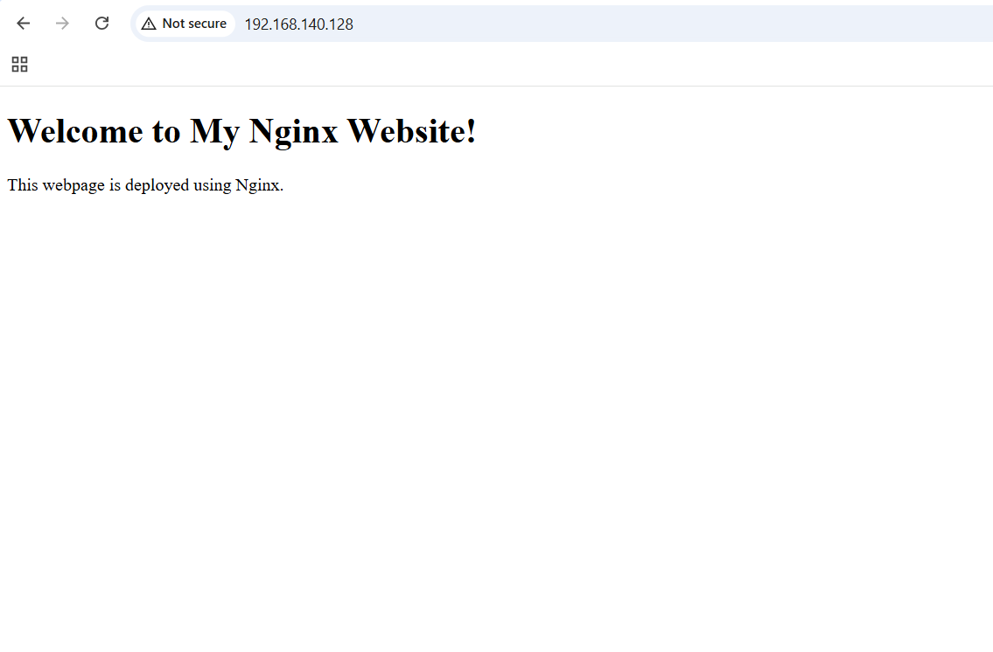
.
Explanation
Nginx is a web server that handles HTTP requests and delivers website content to clients. On Ubuntu, the default website directory is /var/www/html/, where the index.html file can be stored.
In this task, Nginx is installed and started, and a sample HTML file is created in the default web directory. When a user accesses the server's IP address through a browser, Nginx serves the HTML page. The curl command is used to verify the response from the web server.
Real-Time Use Case
Organizations use Nginx to host static websites, company landing pages, documentation portals, and frontend applications. For example, a company can deploy its product information webpage on Nginx so customers can access it through a browser.
Common Errors and Troubleshooting
Error | Cause | Resolution
Nginx command not found | Nginx is not installed | Run sudo apt install nginx -y
Nginx service inactive | Service is stopped | Run sudo systemctl start nginx
Permission denied | Insufficient file permissions | Edit the file using sudo nano /var/www/html/index.html
Default Nginx page appears | HTML file was not saved correctly | Verify /var/www/html/index.html
Connection refused | Nginx is not running or listening on port 80 | Check sudo systemctl status nginx
Browser connection timed out | Firewall or network configuration blocks access | Allow inbound TCP port 80 and verify connectivity
HTTP 403 Forbidden | File or directory access permissions are incorrect | Check permissions and /var/log/nginx/error.log

